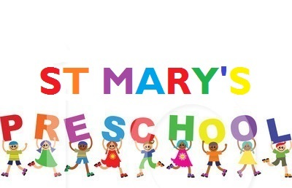
Newsletter – November 2021

Dates for your Diary
- Children In Need Day – Friday 19th November
- Playgroup Closed, training days – 25th and 26th November
- Church Christmas Service – Thursday 9th December. Service starts 09:15
- Playgroup Nativity – Friday 10th December 14:00 (for the children who will be starting school September 2022)
- Children’s Playgroup Christmas Dinner – Monday 13th December (for the children who will be starting school September 2022)
- Children’s Party Day – Friday 17th December, timings tbc.
- Playgroup resumes – Tuesday 4th January 2022

Key Workers - Every child attending St Mary’s Preschool has a key worker. Your child’s key worker is always willing to have a chat about your child with you. A quick word is probably best at the start of a session, this is something most of you do anyway; the end of a session is not good for us. However if you want a longer chat about something specific, we can arrange an appointment during a preschool session to ensure you have the opportunity to talk in private and without interruptions. We would normally prefer not to discuss a child in front of him/her.

Illness - Unfortunately, we are at that time of the year when many infections run rife. As such, below is a quick reminder of the pre-school policy on illness:
- If your child is showing signs of illness, i.e. a high temperature, please keep them at home.
- If they have had sickness or diarrhoea, your child should remain at home for at least 48 hours after the last bout of sickness.
We thank you for your co-operation and understanding of the importance of maintaining a healthy environment for the children and staff.

Nut Free Pre-School – Please remember when packing your child’s lunch box that we are a nut free school and therefore no nuts or nut products should be brought onto the pre-school premises, this includes peanut butter and Nutella chocolate spread.

Fruit Pot - We like to provide healthy snacks to serve at our ‘milk bar’; which on average costs playgroup £10.00 a week. Thank you to those parents who make regular contributions, your donations are really appreciated.

Warm Outdoor Clothing and Naming of coats, hats, gloves etc. – We have such a lovely outdoor garden and Forest school here at St Mary’s and the children love to be outside in it, many of them all day. As the weather starts to get colder please could you send your child in warm clothing and coats, could you also please ensure that all coats, hats, scarves, boots etc are annotated with your child’s name, so many children have the same coat etc as their peers and by naming coats etc this should hopefully ensure your child goes home with the correct apparel.

Sad Farewell to Hayley – We are sorry to say goodbye to Hayley who is leaving us this month, we would like to thank her for her dedication and commitment to St Mary’s preschool during her time here with us.

Friday 19th November – Children in Need Day The children that attend Preschool on Fridays are invited to attend in their pyjamas to celebrate Children in Need. There will be a collection box in the foyer; all money raised will go to Children in Need. Don’t forget Pudsey ears and wristbands are still available at the cost of £2.00 and 50p respectively. Limited stock so buy early.
Special Christmas Post
The red post box will be put out in the foyer the week beginning 29th November for children to post Christmas cards to their friends. Lists of children’s names are available. Last posting date will be Friday 10th December. Cards will be distributed to children during the following week.

Christmas Church Service – Thursday 9th December
Please meet at St Mary’s Church, the service starts at 09:15. Parents are requested to stay for a short service and help us return the children to the Church Hall to continue their playgroup session afterwards.

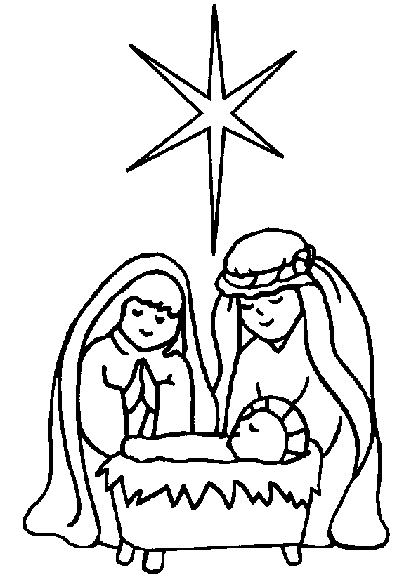
This Photo by Unknown Author is licensed under CC BY-NC-ND
Preschool Nativity – Friday 10th December (Older Group children)
The children will be performing a simple Nativity play on Friday 10th December, starting at 14:00. Due to the ongoing Covid pandemic we may have to introduce some restrictions (guidelines to follow).

Playgroup Christmas Dinner – Monday 13th December (Older Group children)
Tracey will be cooking a Christmas Dinner consisting of roast turkey/vegetarian sausage, sausage and bacon wrap, roast potatoes, Yorkshire pudding, mixed vegetables, followed by jelly/fruit on Monday 13th December. The session will end at 13:30.
Christmas Parties – Friday 17th December Christmas party day will be on Friday 17th December (timings tbc) (please note there are no normal preschool sessions that day and parents are not required to attend).

