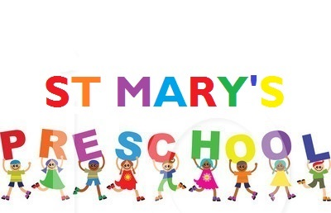
Established 1967
St Mary’s Church Hall, St Mary’s Road, Wootton, Bedford, MK43 9HB
Telephone: 01234 767158
Email: stmarys5@hotmail.co.uk

Newsletter – January 2021

Dear Parents and Carers,

Happy New Year to you all. We hope you all had a lovely Christmas with your family. Even though life stood still for many weeks, the year seems to have flown by. 2020 was an unprecedented year that we will all remember for so many different reasons. We still have a way to go before our lives regain a sense of ‘normal’ but at least there is ‘light at the end of the tunnel’. We want to thank you for partnering with us to keep everyone safe during this pandemic. Your attention to distancing and mask wearing is so appreciated!

Projects This Term
Winter
Chinese New Year
Spring
St David’s Day
St Patrick’s Day
Mother’s Day
Easter

OUTSIDE PLAY
We plan to go outside every day, whatever the weather so please keep sending all that outdoor gear for your child!

KEEPING YOU UP TO DATE
We try to keep you up to date through various means of contact, email, letters home, social media, text etc. If you are not already a member, please consider joining our Facebook group ‘St Mary’s Preschool Wootton’ (CLOSED) group. During the pandemic we will be posting daily activities for you and your child to do at home.

CHILDREN’S PROGRESS FOLDERS
Each child has a progress folder which contains observations, work products and a ‘Learning Profile’ which is the assessment tool for meeting the Early Years Foundation Stage learning and development steps. This folder is available at all times and can be taken home to share with family/friends. Your child’s keyworker is always available to speak to you if required, during the pandemic this will be by telephone. If you would like a telephone appointment, please speak to a member of staff.
EXCITING NEWS
You may have noticed Katie’s waistline expanding over recent weeks! She did not overindulge on chocolate over the Christmas holidays and does have a baby on board! Due to the current pandemic, Katie has had to take her leave now. Everyone at St Mary’s Preschool wishes her all the best and cannot wait to see the new arrival.

World Book Day – Thursday 4th March
This year St Mary’s Preschool will be taking part in World Book Day this will give the children (and staff) an opportunity to dress up as their favourite book character. All children will be given a £1 World Book Day book whether they take part or not.

Red Nose Day – Friday 19th March
This year we will be supporting Red Nose Day. The staff and children are invited to come to school dressed in red or silly clothes.

FEE INCREASE
There will be a fee increase with effect from the start of next half term (22nd February 2021) as follows:

£4.25 per hour
£12.75 per 3-hour session
£25.50 per 6-hour session
£29.75 per 7-hour session

If you have any questions about this or any other matter, then please speak to Tracey.
DATES FOR YOUR DIARY

SPRING TERM
Chinese New Year – Friday 12 February
Half Term 15 – 19 February
World Book Day – Thursday 4 March
Red Nose Day – Friday 19th March
End of Term Friday - Friday 26 March

SUMMER TERM
Term begins - Monday 12 April
Half Term - 31 May – 4 June
End of Term Thursday 22 July

